Project Phase-I - BCSE355L - Cloud Architecture Design
Course Instructor: Dr. Priya V
TOPIC : Intelligent Serverless Workflow Optimization Framework for Smart Hospital Services using Multi-Agent Artificial Intelligence

ABSTRACT
The large quantities of patient and operational data produced by modern hospitals are causing workflow management to become more and more complicated. Traditional hospital systems usually depend on general architectures and human-done coordination, leading to a very long queue in patient admission, inefficient resource allocation, longer waiting times, and overall a loss in productivity.
Existing solutions mainly focus on workflow automation, cloud integration, or AI-driven decision making individually, they do not offer a single framework that brings together intelligent decision-making with scalable cloud infrastructure. Also, usually systems do not support autonomous collaboration among multiple AI agents or serverless computing for cost-efficient and real-time workflow execution.
This project proposes an Intelligent Serverless Workflow Optimization Framework for Smart Hospital Services using Multi-Agent Artificial Intelligence. It employs specialized AI agents responsible for tasks such as patient sorting and prioritizing, appointment based scheduling, bed allocation, resource management, billing, and emergency response. The agents work together, exchange information with one another, and take independent decisions in order to optimize hospital workflows in real time. A serverless architecture ensures automatic scalability, reduced operational costs, and high availability while eliminating the need for dedicated server management.
This system is implemented using Amazon Web Services (AWS), including AWS Lambda for serverless execution, Amazon API Gateway for secure API management, Amazon DynamoDB for scalable NoSQL data storage, Amazon S3 for medical document storage, AWS Step Functions for workflow orchestration, Amazon EventBridge for event-driven communication, Amazon Bedrock for large language model-powered AI agents, and Amazon CloudWatch for monitoring and logging.

LITERATURE SURVEY

Paper | Existing Methods | Method | Dataset | Advantages | Limitations | Research Gap | Possible Improvement
1. Intelligent Serverless Workflow Optimization Framework for Smart Hospital Services using Multi-Agent Artificial Intelligence (Proposed Work) | • Traditional Hospital Information Systems (HIS)• Centralized cloud-based workflow management• Rule-based scheduling systems• Manual resource allocation | • Multi-Agent Artificial Intelligence• Serverless workflow execution• Intelligent task scheduling• Event-driven cloud architecture | • Electronic Health Records (EHR)• Appointment data• Resource utilization records• IoT healthcare sensor data | • Automates hospital workflows• Reduces patient waiting time• Optimizes resource allocation• Scalable and cost-effective architecture• Supports autonomous decision-making | • Prototype framework• Requires real-world deployment• Dependent on cloud infrastructure• Security and privacy challenges | • Existing systems rarely combine Multi-Agent AI with serverless computing• Limited autonomous workflow optimization• Lack of intelligent inter-agent collaboration | • Deploy on AWS cloud platform• Validate using real hospital datasets• Integrate Explainable AI (XAI)• Enhance interoperability with healthcare standards
2. Optimizing Clinical Workflow Using Precision Medicine and Advanced Data Analytics | • Precision medicine approaches• Cloud-based Information Management Systems (IMS)• AI-assisted clinical decision support• Big data analytics | • Artificial Intelligence• Machine Learning• Healthcare Fusion (ROBIN) Framework• Advanced Data Analytics | • Clinical records• Genomic data• Medical records• Healthcare information systems | • Supports personalized healthcare• Improves clinical decision-making• Enhances patient-centered care• Efficient information flow• Promotes precision medicine | • Conceptual framework only• No practical implementation• Limited workflow automation• No autonomous agents | • No Multi-Agent AI architecture• No serverless computing integration• Limited real-time workflow optimization | • Introduce intelligent AI agents• Deploy on AWS serverless services• Incorporate real-time hospital monitoring• Validate with live hospital data
3. A Survey on LLM-based Multi-Agent Systems: Workflow, Infrastructure, and Challenges | • Single-agent AI systems• Traditional LLM applications• Reinforcement learning-based agents | • LLM-based Multi-Agent Systems• Agent communication framework• Workflow architecture• Collaborative reasoning | • Literature survey• Existing Multi-Agent System research• Public benchmarks | • Comprehensive MAS architecture• Explains agent collaboration• Covers reasoning and planning• Discusses communication protocols• Identifies future research directions | • Survey paper only• No practical implementation• Not healthcare-specific• No cloud deployment | • Limited healthcare applications• No hospital workflow optimization• No serverless execution model | • Develop healthcare-oriented MAS• Integrate hospital-specific AI agents• Combine with serverless cloud platforms• Evaluate in smart hospital environments
4. Combining Machine Learning and Optimization for the Operational Patient-Bed Assignment Problem | • Manual patient-bed assignment• Rule-based optimization• Traditional forecasting methods | • Machine Learning forecasting• Hyper-Heuristic optimization• Emergency patient prediction• Greedy Look-Ahead heuristic | • Real hospital patient-bed assignment data• Emergency patient records• Hospital occupancy data | • Improves bed allocation accuracy• Better emergency admission prediction• Optimizes hospital capacity utilization• Reduces resource wastage• Uses real-world hospital data | • Limited to bed assignment problem• Doesn't optimize complete hospital workflow• No autonomous decision-making | • No Multi-Agent AI• No cloud-native workflow management• Limited hospital-wide optimization | • Extend to hospital-wide workflow optimization• Add autonomous AI agents• Integrate appointment and staff scheduling• Deploy using cloud services
5. Blockchain-Based Healthcare Workflow for Tele-Medical Laboratory in Federated Hospital IoT Clouds | • Blockchain-based healthcare systems• IoT-enabled telemedicine• Federated cloud computing | • Blockchain technology• Smart contracts• IoT-enabled healthcare workflow• Federated cloud architecture | • IoT healthcare data• Electronic Health Records• Telemedicine laboratory data | • Secure medical data sharing• Improves interoperability• Ensures data integrity• Supports decentralized healthcare• Enhances patient data privacy | • No Artificial Intelligence• No Multi-Agent collaboration• High computational overhead• Focuses mainly on security | • Missing intelligent workflow optimization• No autonomous healthcare agents• No predictive decision-making | • Combine Blockchain with Multi-Agent AI• Integrate predictive analytics• Implement serverless cloud architecture• Enable autonomous resource management
6. Multi-Agent Systems in Fog–Cloud Computing for Critical Healthcare Task Management Model (CHTM) Used for ECG Monitoring | • Cloud computing for healthcare• Fog computing• Conventional resource scheduling• IoT-based ECG monitoring | • Multi-Agent System (MAS)• Fog–Cloud architecture• Dynamic task scheduling• Critical Healthcare Task Management (CHTM) | • ECG monitoring dataset• Fog–Cloud simulation data• Healthcare IoT workload | • Reduces response time and latency• Improves resource utilization• Supports dynamic task allocation• Enhances interoperability• Reduces network usage and energy consumption | • Limited to ECG monitoring• Simulation-based evaluation• No hospital-wide workflow optimization• No serverless implementation | • Limited support for multi-department hospitals• No autonomous workflow optimization across hospital services• No cloud-native serverless architecture | • Extend to complete hospital workflows• Integrate AWS Lambda and Step Functions• Support multiple hospital departments• Add intelligent workflow prediction
7. The Role of AI in Hospitals and Clinics: Transforming Healthcare in the 21st Century | • Clinical Decision Support Systems (CDSS)• AI-assisted diagnosis• Medical imaging analysis• Hospital management systems | • Artificial Intelligence• Machine Learning• Deep Learning• Healthcare analytics | • Healthcare case studies• Medical imaging datasets• Clinical records• Literature review | • Comprehensive review of AI applications• Improves diagnosis accuracy• Supports personalized medicine• Enhances hospital management• Discusses ethical AI considerations | • Review paper only• No implementation framework• Limited workflow automation discussion• No Multi-Agent AI | • No intelligent autonomous workflow architecture• No serverless deployment model• Limited discussion of AI collaboration | • Build AI-driven workflow automation framework• Introduce Multi-Agent collaboration• Deploy using AWS cloud services• Integrate IoT-enabled monitoring
8. Innovative Robotic Technologies and Artificial Intelligence in Pharmacy and Medicine: Paving the Way for the Future of Health Care | • Robotic Process Automation (RPA)• Medical robotics• AI-assisted healthcare systems• Pharmacy automation | • Artificial Intelligence• Robotics• Automation technologies• Smart healthcare systems | • Literature review• Healthcare and pharmacy applications• Robotic healthcare systems | • Improves precision and efficiency• Reduces repetitive manual tasks• Supports drug discovery and pharmacy automation• Enhances patient care quality• Promotes healthcare innovation | • Mainly review-based• Focuses more on robotics than workflow optimization• Limited cloud integration• No autonomous multi-agent coordination | • Missing hospital workflow optimization• No cloud-native architecture• No intelligent collaborative AI agents | • Integrate robotic systems with Multi-Agent AI• Develop autonomous hospital workflow management• Incorporate serverless cloud deployment• Enable real-time decision support
9. Solutions for Improved Hospital-wide Patient Flows – A Qualitative Interview Study of Leading Healthcare Providers | • Lean healthcare practices• Manual workflow coordination• Capacity planning• Process improvement methodologies | • Qualitative analysis• Interview-based framework• Patient flow optimization• Hospital process redesign | • Interviews with 33 senior managers• 18 leading hospitals across 9 countries | • Identifies practical workflow improvement strategies• Improves patient flow• Optimizes hospital capacity utilization• Provides management framework• Focuses on organization-wide improvement | • No AI-based automation• Manual optimization strategies• No predictive analytics• No implementation of intelligent systems | • Lack of autonomous workflow management• No Multi-Agent AI support• Limited real-time optimization | • Introduce AI-based predictive patient flow management• Automate coordination using intelligent agents• Deploy cloud-based workflow optimization• Use real-time hospital analytics
10. Automation of Hospital Workflows Using International Standards: A Case Study with Imaging Exams | • HL7 messaging standards• openEHR• Traditional Electronic Health Records (EHR)• Standards-based workflow management | • openEHR Task Planning (TP)• Workflow automation• Clinical decision rules• Standardized healthcare interoperability | • Over 6,800 imaging exam requests• Hospital imaging workflow• Electronic Health Records | • Improves workflow standardization• Enhances interoperability• Reduces waiting time• Generates structured healthcare data• Successfully deployed in a real hospital | • No AI-based decision-making• Static workflow execution• No autonomous learning capability• Limited to imaging workflow | • Missing intelligent workflow adaptation• No Multi-Agent collaboration• No serverless cloud integration | • Integrate Multi-Agent AI for adaptive workflow optimization• Use AWS Step Functions and Lambda for orchestration• Expand to all hospital departments• Add predictive resource allocation
11. Agentic AI in Healthcare: Opportunities, Challenges, and Future Directions | • Traditional AI-based healthcare systems• Clinical Decision Support Systems (CDSS)• Large Language Models (LLMs)• Rule-based healthcare automation | • Agentic AI framework• Autonomous AI agents• Multi-agent collaboration• LLM-powered healthcare intelligence | • Healthcare benchmark datasets• Published case studies• Existing healthcare AI research | • Enables autonomous decision-making• Supports collaborative problem-solving• Improves workflow automation• Discusses ethical and regulatory aspects• Identifies future research directions | • Survey paper only• No practical implementation• No real hospital deployment• No serverless architecture | • Limited real-world validation• No cloud-native implementation• Lack of integration with hospital information systems | • Implement Agentic AI using AWS Bedrock• Deploy on AWS Lambda and Step Functions• Validate in real hospital environments• Integrate with Electronic Health Records (EHR)
12. The Role of Agentic AI in Healthcare: A Scoping Review | • Autonomous AI assistants• Clinical AI applications• Decision-support systems• Intelligent healthcare automation | • Scoping review methodology• Agentic AI analysis• Literature synthesis• Healthcare application evaluation | • Seven healthcare research studies• Published scientific literature | • Summarizes current Agentic AI applications• Highlights opportunities and challenges• Identifies future research trends• Encourages intelligent healthcare automation | • Limited number of reviewed studies• No experimental validation• Early-stage research area• Limited deployment evidence | • Insufficient large-scale clinical evaluation• Limited workflow optimization research• No serverless cloud deployment | • Develop real-world healthcare applications• Expand large-scale validation studies• Integrate with Multi-Agent architectures• Evaluate cloud-based deployment
13. The Internet of AI Agents (IAIA): A New Frontier in Networked and Distributed Intelligence | • Internet of Things (IoT)• Distributed AI systems• Federated Learning• Cloud-edge computing | • Internet of AI Agents (IAIA)• Distributed autonomous agents• Agent communication protocols• Collaborative intelligence | • Conceptual architecture• AI networking research• Literature review | • Supports scalable AI collaboration• Enables distributed intelligence• Improves autonomous communication• Suitable for complex distributed environments• Encourages interoperability | • Conceptual framework only• No healthcare implementation• No experimental validation• Infrastructure complexity | • Limited healthcare applications• No hospital workflow optimization• No serverless integration | • Design healthcare-specific IAIA architecture• Integrate hospital IoT devices• Combine with AWS serverless services• Evaluate intelligent hospital coordination
14. An Autonomous Energy-Aware Resource Scheduling Mechanism in Serverless Edge Computing | • Traditional serverless scheduling• Edge computing• Static resource allocation• Cloud resource management | • Autonomous Energy-Aware Scheduling Mechanism (AEASM)• MAPE-K architecture• Dynamic workload scheduling• Edge-serverless computing | • Serverless edge workloads• Simulation datasets• Resource scheduling benchmarks | • Improves resource utilization• Reduces energy consumption• Enhances scalability• Supports autonomous adaptation• Improves response time | • Generic serverless framework• Not healthcare-specific• Simulation-based evaluation• No AI-driven clinical workflow | • No hospital workflow optimization• Missing healthcare use cases• No Multi-Agent collaboration | • Customize scheduling for healthcare workloads• Integrate Multi-Agent AI• Optimize emergency healthcare services• Validate using hospital datasets
15. Proposed Intelligent Serverless Workflow Optimization Framework for Smart Hospital Services using Multi-Agent AI | • Hospital Information Systems (HIS)• AI-assisted scheduling systems• Cloud-based workflow management• Existing healthcare automation frameworks | • Multi-Agent Artificial Intelligence• AWS Serverless Architecture• Event-driven workflow orchestration• Intelligent resource optimization | • Electronic Health Records (EHR)• Appointment scheduling data• IoT sensor data• Hospital resource utilization records• Patient monitoring data | • Intelligent workflow automation• Autonomous decision-making• Dynamic resource allocation• Reduced infrastructure cost• Highly scalable and fault tolerant• Faster response time through serverless execution• Improved patient care and operational efficiency | • Prototype requires implementation• Dependent on cloud availability• Data privacy and compliance challenges• Requires integration with existing hospital systems | • Existing studies do not combine Multi-Agent AI, AWS serverless computing, and smart hospital workflow optimization into a unified framework• Limited research on autonomous healthcare workflow orchestration using cloud-native services | • Implement and validate the framework in real hospitals• Integrate Explainable AI (XAI) for transparency• Strengthen cybersecurity and compliance measures• Expand support for telemedicine and IoT healthcare devices• Compare performance with existing hospital workflow systems

Project Objectives
- Develop an intelligent serverless workflow optimization framework for smart hospital services using Multi-Agent Artificial Intelligence to automate task scheduling and resource management.
- Reduce workflow response time and improve operational efficiency by using AWS serverless services such as AWS Lambda, AWS Step Functions, and Amazon EventBridge for event-driven workflow execution.
- Optimize hospital resource utilization by enabling AI agents to dynamically allocate medical staff, hospital beds, equipment, and appointment schedules based on real-time demand.
- Ensure secure, scalable, and reliable healthcare data management using AWS cloud services such as Amazon DynamoDB, Amazon S3, and IAM while maintaining patient data privacy and system availability.
- Provide real-time monitoring and intelligent decision support through AI-driven workflow analysis, automated notifications, and cloud-based dashboards to assist healthcare administrators in making informed decisions.
- Evaluate the performance of the proposed framework by measuring key metrics such as workflow execution time, resource utilization, scalability, system throughput, and overall operational efficiency in a smart hospital environment.

NOVELTY SUMMARY
1. New Feature
Introduces Multi-Agent AI for autonomous coordination of hospital workflows.
Enables intelligent collaboration among multiple AI agents handling appointments, hospital beds, staff scheduling, equipment allocation, and emergency cases.
Supports real-time monitoring and adaptive decision-making based on hospital conditions.
2. Better Algorithm
Uses Multi-Agent AI-based intelligent decision-making instead of traditional rule-based or static scheduling methods.
Dynamically prioritizes and allocates healthcare resources according to real-time patient demand.
Continuously optimizes workflow execution to reduce delays and improve service quality.
3. Better Architecture
Implements a serverless, event-driven architecture on AWS.
Eliminates the need for dedicated server management.
Provides modular, fault-tolerant, and highly available workflow execution.
Easily integrates with existing Hospital Information Systems (HIS) and Electronic Health Records (EHR).
4. Better AWS Integration
Utilizes AWS Lambda for serverless function execution.
Uses AWS Step Functions for workflow orchestration.
Employs Amazon EventBridge for event-driven communication.
Stores healthcare data securely using Amazon DynamoDB and Amazon S3.
Integrates Amazon Bedrock for advanced AI capabilities.
Uses AWS CloudWatch for monitoring and AWS IAM for secure access control.
5. Better Security
Protects sensitive patient information through secure cloud storage.
Implements role-based access control using AWS IAM.
Supports encrypted data storage and secure API communication.
Provides audit logging and secure authentication to improve healthcare data protection.
6. Better Automation
Automates workflow execution with minimal human intervention.
AI agents automatically assign medical staff, hospital beds, and equipment.
Sends automated notifications and updates for hospital events.
Reduces manual administrative workload and human errors.
7. Better Accuracy
Makes intelligent decisions using real-time hospital data.
Improves appointment scheduling and resource allocation accuracy.
Minimizes scheduling conflicts and resource wastage.
Enhances overall workflow efficiency and patient care.
8. Better Scalability
Automatically scales computing resources based on hospital workload.
Handles increasing numbers of patients without performance degradation.
Supports hospitals of different sizes without requiring infrastructure changes.
Reduces operational costs through AWS pay-as-you-use serverless services.

Proposed Architecture
Diagram 1- AWS Cloud Architecture
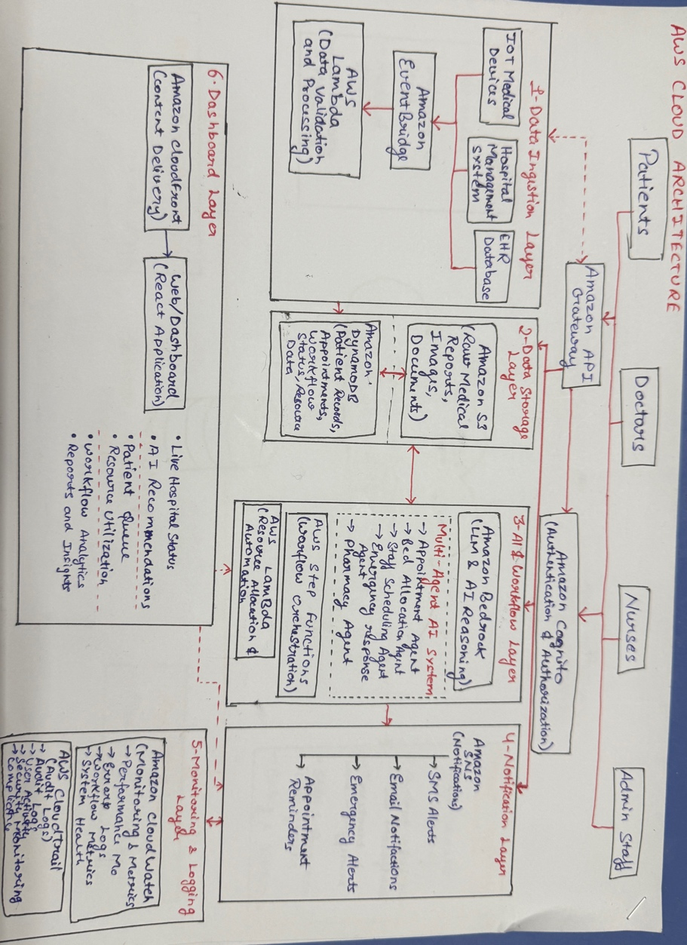
Diagram 2- Complete System Architecture
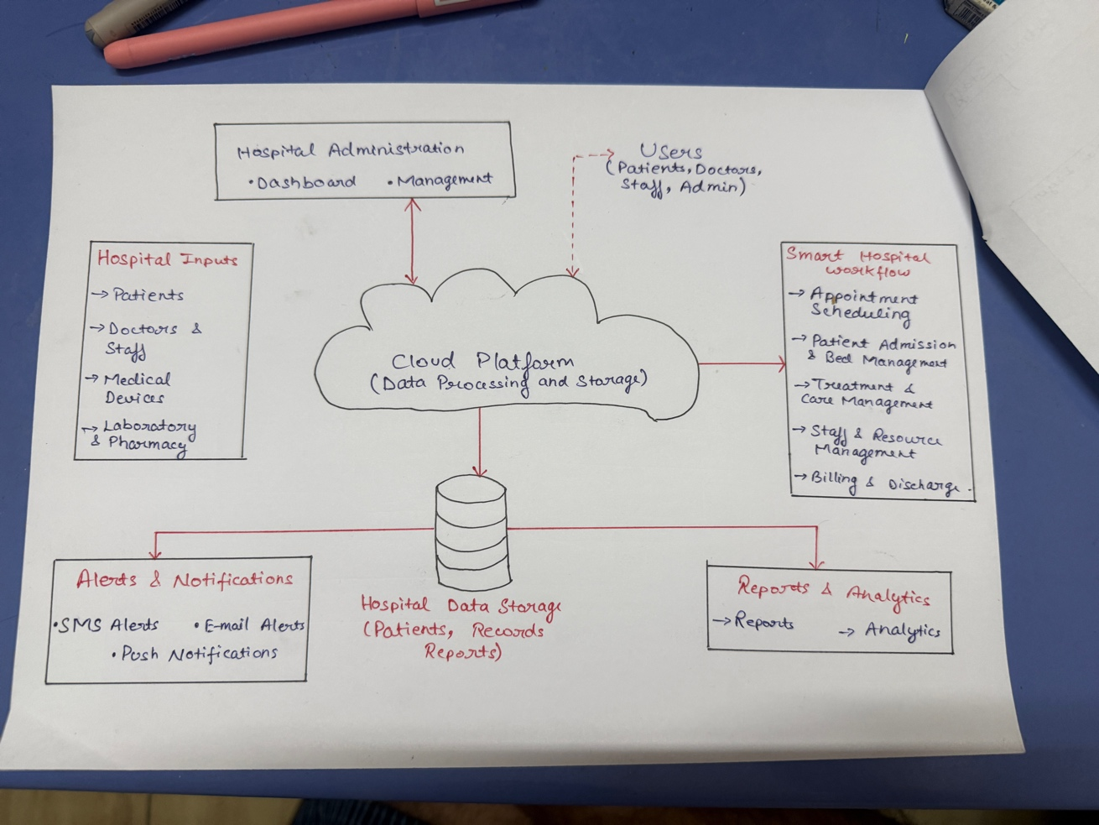

AWS Services Planning
AWS Service | Purpose in the Project
Amazon API Gateway | Provides secure REST APIs for communication between the hospital application, AI agents, and backend services.
Amazon Cognito | Handles user authentication and authorization for patients, doctors, nurses, and administrators.
AWS Lambda | Executes serverless functions for workflow processing, appointment scheduling, resource allocation, and AI task execution.
AWS Step Functions | Orchestrates multi-step hospital workflows such as patient admission, treatment, discharge, and emergency handling.
Amazon EventBridge | Enables event-driven communication between different hospital services and AI agents.
Amazon Bedrock | Provides foundation models to power Multi-Agent AI, intelligent reasoning, and natural language interactions.
Amazon DynamoDB | Stores structured hospital data such as patient records, appointments, workflow status, and resource availability.
Amazon S3 | Stores medical reports, scanned documents, prescriptions, diagnostic images, and backup files securely.
Amazon SNS (Simple Notification Service) | Sends appointment reminders, emergency alerts, SMS, email, and push notifications to users.
Amazon CloudWatch | Monitors application performance, workflow execution, system metrics, logs, and generates alerts.
AWS CloudTrail | Records user activities and API calls for auditing, compliance, and security monitoring.
AWS IAM (Identity and Access Management) | Manages secure access to AWS resources using role-based permissions and access policies.
AWS Backup | Performs automated backups of hospital data and supports disaster recovery.
Amazon CloudFront (Optional) | Delivers the hospital dashboard and web application with low latency and improved performance.

